Shrinkage correlation: GBPUSD and USDCAD
Method 08 / eight-major panel / delta = 0.2 and Ledoit-Wolf / Alpari D1 full available history

Study setup
Logical pair: GBPUSD , USDCAD
Broker symbols: GBPUSD_i , USDCAD_i
Snapshot: 2026-11-03_majors_alpari_D1
Timeframe: D1
Common eight-major panel window: 1999-01-06 to 2026-11-02 (UTC bar dates)
Panel matched return count n: 7127
Dropped unfinished last bar dated 2026-11-03 UTC after a tick-volume check against the prior complete day.
Fixed shrinkage: delta=0.2, mu=3.9170889e-05 (mean of diag(S))
Ledoit-Wolf estimated delta: 0.0042157642
Panel symbols: EURUSD, GBPUSD, AUDUSD, NZDUSD, USDJPY, USDCHF, USDCAD, EURGBP
Complete matched rows (Excel): GBPUSD-USDCAD_Shrinkage_D1.xlsx
Complete matched rows (HTML table): GBPUSD-USDCAD_Shrinkage_D1_data.html

Method carried forward
Shrinkage blends the sample covariance matrix S of matched daily log returns of close, ln(close_t / close_t-1), toward a simple target, then converts the shrunk covariance into correlations. Quotes are not inverted. This experiment builds one common calendar across all eight majors, forms S with the unbiased n-1 divisor, then reports two shrinkage specs: fixed delta = 0.2 with mu equal to the average sample variance (mu * I target), and sklearn Ledoit-Wolf with its estimated delta. Pair reports pull rho_ij from those panel matrices. Same-panel Pearson r is a side check only. Shrinkage improves conditioning; it is not a cause, not a lead, and not a trading signal.

Results
pearson_r | rho_02 | rho_LW | rho_02_minus_r | rho_LW_minus_r | delta_LW
-0.457478 | -0.341922 | -0.454872 | 0.115556 | 0.002606 | 0.00421576

Conclusion
Over the common 7127-day eight-major panel for GBPUSD and USDCAD (broker quote directions unchanged), fixed-delta shrinkage correlation at delta=0.2 is -0.3419 (negative, weak linear link in this sample). Ledoit-Wolf rho is -0.4549 with estimated delta=0.004216. Same-panel Pearson r is -0.4575 (rho_02 minus r = 0.1156; rho_LW minus r = 0.0026). This does not establish cause, lead-lag, or a lasting trading rule.

Charts
Daily closes
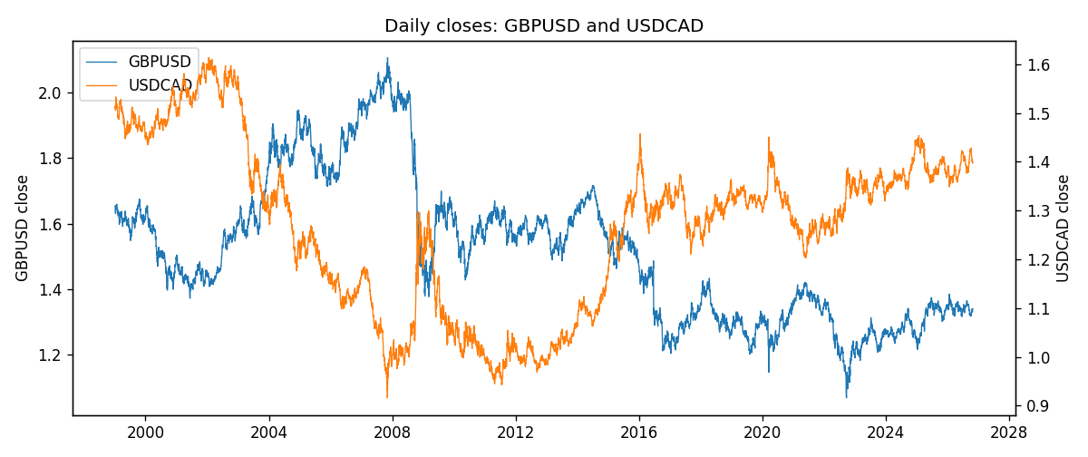
Daily log returns
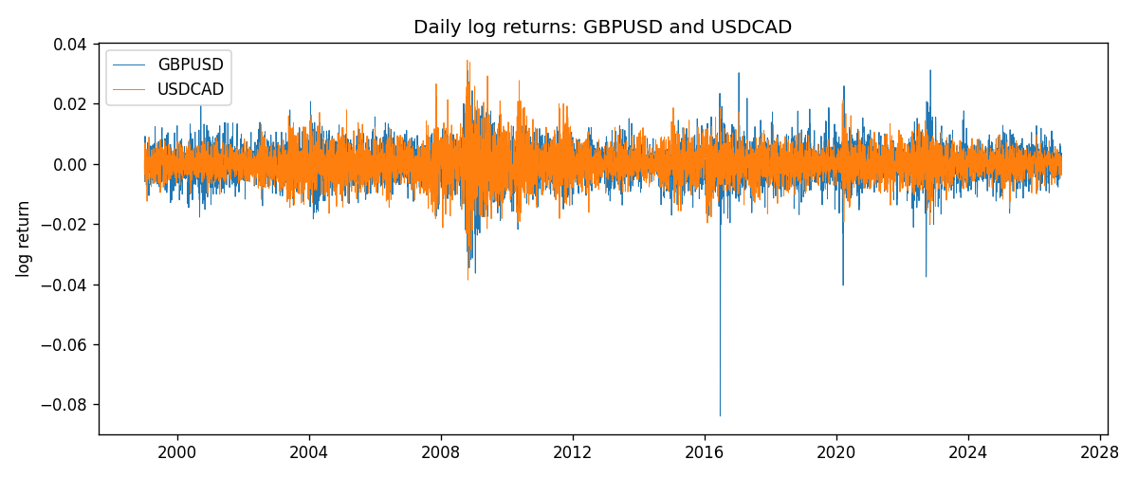
Log-return scatter
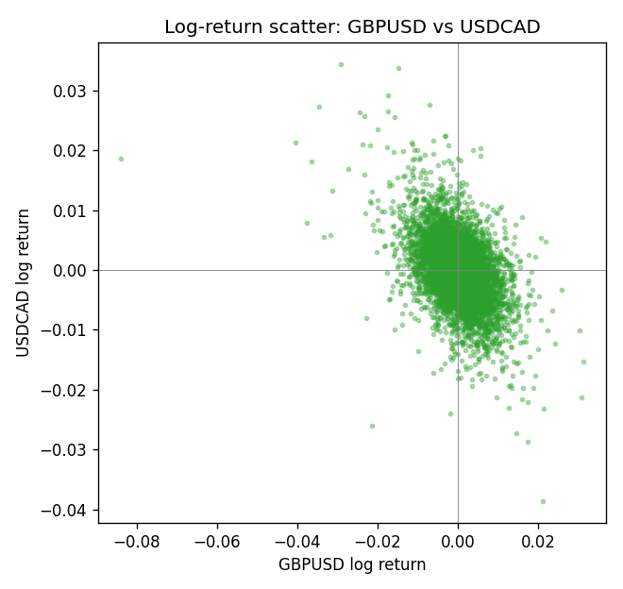

Data report
Every panel row for this pair slice is stored in the sibling Excel workbook named GBPUSD-USDCAD_Shrinkage_D1.xlsx. Full-panel covariance and correlation matrices are saved once under outputs/ as CSV files. Embedding all rows as a Word table is impractical at this length; the Word file holds the column list, column summaries, and the first and last 15 matched rows.
Columns: time, GBPUSD_open, GBPUSD_high, GBPUSD_low, GBPUSD_close, GBPUSD_tick_volume, GBPUSD_spread, GBPUSD_real_volume, GBPUSD_log_return, USDCAD_open, USDCAD_high, USDCAD_low, USDCAD_close, USDCAD_tick_volume, USDCAD_spread, USDCAD_real_volume, USDCAD_log_return
Column summaries (panel rows)
column | count | mean | std | min | 25% | 50% | 75% | max
GBPUSD_open | 7127 | 1.5143204 | 0.21800183 | 1.06854 | 1.323655 | 1.5093 | 1.62967 | 2.1066
GBPUSD_high | 7127 | 1.5206136 | 0.21856742 | 1.08366 | 1.32882 | 1.5159 | 1.636975 | 2.1161
GBPUSD_low | 7127 | 1.508003 | 0.21722806 | 1.03518 | 1.3185 | 1.501 | 1.623 | 2.0983
GBPUSD_close | 7127 | 1.5143843 | 0.21795834 | 1.06879 | 1.32373 | 1.5095 | 1.62965 | 2.1065
GBPUSD_tick_volume | 7127 | 95725.777 | 154086.85 | 62 | 10131.5 | 53562 | 92170 | 1273370
GBPUSD_spread | 7127 | 26.790936 | 19.185969 | 0 | 10 | 20 | 50 | 50
GBPUSD_real_volume | 7127 | 3.5930129e+09 | 8.4874724e+10 | 0 | 0 | 0 | 0 | 2.4038164e+12
GBPUSD_log_return | 7127 | -2.548e-05 | 0.00564718 | -0.08388241 | -0.00312586 | 3.034e-05 | 0.00318105 | 0.03112653
USDCAD_open | 7127 | 1.2660158 | 0.16869092 | 0.9168 | 1.11698 | 1.29814 | 1.371685 | 1.6183
USDCAD_high | 7127 | 1.2709144 | 0.16864061 | 0.9336 | 1.122275 | 1.30368 | 1.37575 | 1.619
USDCAD_low | 7127 | 1.2614634 | 0.1687284 | 0.9056 | 1.112315 | 1.29315 | 1.36729 | 1.6102
USDCAD_close | 7127 | 1.2660395 | 0.16866578 | 0.916 | 1.116855 | 1.298 | 1.371955 | 1.6137
USDCAD_tick_volume | 7127 | 81672.889 | 147760.33 | 56 | 5669.5 | 41299 | 71973 | 1410818
USDCAD_spread | 7127 | 23.249895 | 18.19595 | 0 | 9 | 17 | 40 | 60
USDCAD_real_volume | 7127 | 1.8530805e+10 | 9.7086285e+10 | 0 | 0 | 0 | 0 | 2.5751613e+12
USDCAD_log_return | 7127 | -7.67e-06 | 0.00514753 | -0.03859748 | -0.0028338 | 5.597e-05 | 0.00272861 | 0.03436319
First 15 panel rows (selected columns)
time | GBPUSD_close | USDCAD_close | GBPUSD_log_return | USDCAD_log_return
1999-01-06 | 1.6537 | 1.5118 | -0.00060452184 | -0.0003306769
1999-01-07 | 1.6502 | 1.5141 | -0.002118709 | 0.0015202092
1999-01-08 | 1.6405 | 1.511 | -0.0058954193 | -0.0020495197
1999-01-11 | 1.6312 | 1.5057 | -0.0056851331 | -0.0035137769
1999-01-12 | 1.6349 | 1.5157 | 0.0022657001 | 0.0066194721
1999-01-13 | 1.6499 | 1.5226 | 0.0091330396 | 0.0045420214
1999-01-14 | 1.6531 | 1.5332 | 0.0019376331 | 0.0069376546
1999-01-15 | 1.6502 | 1.5245 | -0.0017558204 | -0.0056905671
1999-01-18 | 1.6522 | 1.526 | 0.0012112405 | 0.00098344542
1999-01-19 | 1.6553 | 1.5302 | 0.0018745281 | 0.002748513
1999-01-20 | 1.6472 | 1.5211 | -0.0049053846 | -0.0059646885
1999-01-21 | 1.6524 | 1.5146 | 0.0031518998 | -0.0042823796
1999-01-22 | 1.6565 | 1.5184 | 0.0024781662 | 0.0025057712
1999-01-25 | 1.6585 | 1.5197 | 0.0012066366 | 0.00085579808
1999-01-26 | 1.6597 | 1.52 | 0.00072328374 | 0.0001973879
Last 15 panel rows (selected columns)
time | GBPUSD_close | USDCAD_close | GBPUSD_log_return | USDCAD_log_return
2026-10-13 | 1.32534 | 1.4214 | 0.0036434319 | -0.0046395653
2026-10-14 | 1.31884 | 1.42356 | -0.0049164679 | 0.0015184751
2026-10-15 | 1.32757 | 1.41843 | 0.0065976411 | -0.0036101503
2026-10-16 | 1.33257 | 1.41357 | 0.0037592051 | -0.0034322068
2026-10-19 | 1.33024 | 1.41091 | -0.0017500314 | -0.0018835331
2026-10-20 | 1.3377 | 1.40569 | 0.0055923442 | -0.0037066008
2026-10-21 | 1.33937 | 1.4045 | 0.0012476328 | -0.00084691787
2026-10-22 | 1.33967 | 1.40081 | 0.00022396082 | -0.0026307268
2026-10-23 | 1.33684 | 1.40085 | -0.0021146949 | 2.85545e-05
2026-10-26 | 1.33359 | 1.40093 | -0.0024340661 | 5.7106554e-05
2026-10-27 | 1.33044 | 1.40449 | -0.0023648393 | 0.0025379458
2026-10-28 | 1.33254 | 1.39911 | 0.0015771808 | -0.0038379274
2026-10-29 | 1.33733 | 1.39895 | 0.0035881935 | -0.00011436495
2026-10-30 | 1.33913 | 1.39751 | 0.0013450605 | -0.0010298736
2026-11-02 | 1.3406 | 1.39837 | 0.0010971256 | 0.00061519094

